MedCommons Laboratories

Business Summary

July 17, 2003

Contents

Vision

MCL Services

Benefits

Team

Plan

Appendix

A: MedCommons Executive Summary

B: MedCommons DigitalYou™

C: Bios

Contact:
Adrian Gropper, M.D.
617-571-3857
agropper@med-commons.org
www.med-commons.org

Vision

MedCommons Laboratories (MCL) is a for-profit patient and physician Web services business

MCL provides anonymous and confidential access to the DigitalYou™ data and code base for computerized human image analysis by patients and physicians as a service over the Internet.

MCL provides patients and physicians meaningful, high quality analyses of CT, MRI and other high-resolution images in a branded, cost-effective and FDA-regulated manner.

Access to MCL services will be free to all patients and supported through voluntary opt-in by patients to targeted and private solicitation by sponsoring imaging facilities, pharmaceutical vendors and medical device manufacturers.

MedCommons Laboratories services will give patients and physicians unprecedented transparency and control over the critical choices they make as they manage an increasingly complex and expensive health management system. This transparency will reduce overall health care costs by reducing the amount of unnecessary therapeutic procedures that have been shown to account for as much as 30% of total health care expenditures. It is important to note that the objective, transparent, Open Source, evidence-based approach promoted by MedCommons Laboratories serves the portability mandate of the Health Information Portability and Accountability Act of 1996 (HIPAA) and does not depend on new and politically difficult regulations.
MCL Services

Anonymous Medical Image and Data Analysis

A high quality, data-centric Web Services Business (“Amazon for Healthcare”)

Using Open Source, Peer-Reviewed Methods as available

Exposes Web Services Interface to thousands of Disease-Oriented Affiliates

Accepts images and returns annotated images with absolute Patient Control

Free to the Patient and Physician

Patient Opt-in for Imaging Center Referral

MedCommons compliant Imaging Centers listed geographically

Imaging Center Pays for Referrals

Patient Opt-in for Pharma / Device Referral

Manufacturer Pays for Referrals

Physician / Patient Opt-in to DigitalYou™ Curated Data Bank

Free to Physicians and Manufacturers

Pro-Forma Clinical Analysis Menu

Diabetic Retinopathy Screening

Lung Cancer Screening

Coronary Calcium Scoring

Virtual Colonoscopy

Abdominal Aortic Aneurysm Treatment Planning

Tumor Volume Measurement

Mammography Screening

Radiation Treatment Planning

EKG Interpretation

Holter Monitoring

Step-by-Step Description

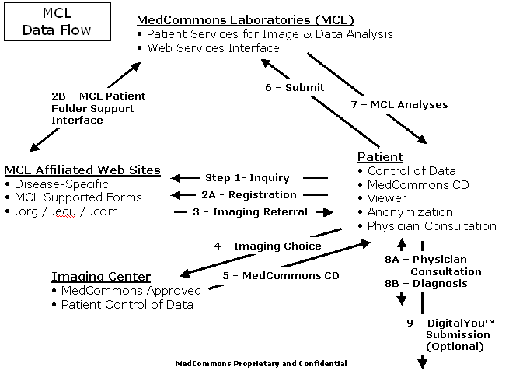
NOTES:

Step 1 – An MCL Affiliated Web Site does not have to store or process any patient-specific data. MCL-aware Web pages interact with MCL Web Services that provide Patient Folder support in a reliable and fully customizable manner.

4 - The Imaging Center choice is a Patient Opt-In. MedCommons Approved facilities always return images to the patient in a manner that allows the patient and their physician full HIPAA-mandated control over all subsequent uses of the images.

7 - MCL Analyses may offer Patient Opt-In to highly targeted solicitations from pharmaceutical and medical device manufacturers. The use of anonymity and Open Source software guarantees Patient Control and maximum privacy.

8 - Consulting physicians can use the same free software that MedCommons makes available to the Patient. However, because MedCommons software is Open Source, physician software vendors will have no barrier to incorporating MedCommons and MCL Web Services technology into their professional products.

9 - DigitalYou™ is the MedCommons trademark for The Human Imaging Project that includes the universe of images and evidence-based diagnostic conclusions that patients and their physicians have voluntarily donated to the public commons. DigitalYou™ data will be curated and stored by a variety of academic, charitable and commercial users to assist in the development of ever more sophisticated Computer Assisted Diagnosis (CAD) software and services.
Benefits

Health Care Waste Reduction

30% of care is Unwarranted

Increased Diagnostics Access

Decreased Therapy Costs

Increased Transparency, Privacy, Innovation, and Peer-Review

Market-based Control of Direct-to-Consumer Advertising

Team

Co-Founders

Adrian Gropper, M.D.

Hugh Cottingham

Sean Doyle

Management

TBD

Medical Device Professionals

FDA 510[k] Experience

Teleradiology Experience

Open Source Software Expertise

MGH Affiliation

Plan

MedCommons Laboratories.com

Online Patient Services

Computer and Storage Operations (Outsourced?)

MedCommons.org

Leadership in Patient Control

Trademark management

FDA Registration Methods

Mitigates the Risk of Advanced Computer Technology

Demonstrates Community-based Free/Open Source Software Development for Healthcare

Oversight

MGH

MIT

Clinical Trials Consortia

Sponsors

IBM

Analog Devices

Novell

 Executive Summary July 2003

Vision
Improve U.S. healthcare through patient control of medical images.

Market Strategy
MedCommons will be the first non-profit organization to develop and distribute FDA cleared, Open-Source, medical web services applications for individuals and physicians. MedCommons will be directly supported by one or more for-profit ventures that benefit from direct patient control of medical information. These include diagnostic imaging systems manufacturers, pharmaceutical and minimally invasive therapy manufacturers and Internet providers of automated image interpretation laboratory services.

Opportunity
Medical imaging is now an integral and growing part of modern health care. Currently, there is often no way for patients to access their digital medical images (CT, MR, etc.) without a lot of bureaucratic red tape. Not being in control of their medical images results in patients experiencing unnecessary difficulty when dealing with complex medical situations and difficulty in getting objective information about their treatment options. Patient control of medical images, through effortless portability across institutional boundaries, will eliminate these difficulties and enable emerging computational medicine web services. This will offer the patient the possibility of separating diagnosis from treatment decisions, along with enhancing the role of the primary care practitioner as patient advisor, for treatment that is more fully aligned with the patient’s best interests and wishes.

Mission

Digital You™, The Human Imaging Project connects patients, doctors and software developers. It is the project for discovering how to use imaging with computational medicine to provide objective analysis, reduce unnecessary treatment and increase patient control. The project promotes community based development of FDA cleared, HIPAA aware, open source software.

Business Strategy
Open Source software has a natural advantage in applications where both customers and suppliers benefit from a non-proprietary platform. The rapid market acceptance of Linux and its support by IBM illustrate this point. Medical software, however, requires FDA clearance appropriate to its intended use and distribution. MedCommons will be a market leader, known to define, implement and promote an Open Source platform for medical applications. Digital You™ software and MedCommons protocols are designed to support the full range of emerging computational medicine services whether delivered as Web services, Open Source or proprietary software to patients and physicians alike.

Organization Strategy
Non-profit. On going software registration services and support operations will be supported by referral fees paid by pharmaceutical, medical device and laboratory services vendors. MedCommons will contribute to strategically important open source diagnostic software developers including universities and academic medical research centers.

Financials
MedCommons is seeking $2 million in sponsor funding to launch the organization and fund it for the first year.

Community Enhanced Healthcare

As pharmaceutical and less invasive medical technology continues to entice and demand more of our attention (and income), the role of individual patients and physicians will tend to increase relative to large institutions such as hospitals and insurers. The recent success of global community-based software development, also called Free and Open Source Software (F/OSS), teaches us that individuals with diverse and primarily non-economic motivations can organize via the Internet to deliver valuable services to each other and to the world at large when traditional institutions stand in the way of innovation or raise unacceptable doubts.

MedCommons is conceived as a catalyst for community-based Free / Open Source Software development in healthcare. Projects influenced by MedCommons will serve the public interest and promote rapid healthcare innovation by dis-integrating diagnosis from therapy through broadly accessible, peer-reviewed Internet-based image and data analysis. The use of Open Source Software to support medical decisions will reduce the cost of high quality health care by reducing the unwarranted variations that are said to account for some 30% of today’s health care cost. MedCommons-led Open Source Software will act as an objective intermediary between the purveyors of pharmaceuticals and medical devices and the patients and their physicians.

Technically, MedCommons will be organized and operated as a not-for-profit, and affiliated with one or more major scientific organizations interested in bringing medical scientific advances to patients as quickly as possible. MedCommons will develop methods for development and distribution of Open Source Software that conform with FDA medical device regulations. MedCommons will enable community-enhanced healthcare by lowering the regulatory barriers that are unique to high-risk healthcare software such as that used for screening and treatment planning.

MedCommons will also promote medical science by making it much easier and more rewarding for patients and physicians to contribute their increasingly valuable high-resolution data sets to the global library of genotypic and phenotypic information. A positive feedback effect is anticipated, as this free library is essential to the development of more effective computer assisted diagnosis programs.

MedCommons was founded by three medical device industry professionals with leading credentials in diagnostics, telemedicine and large-scale medical image management. In 2002, a policy level meeting with the Director of the FDA Center for Devices and Radiological Health and his staff established the guidelines under which the FDA would review Open Source Software. Private demonstrations of one Open Source medical data archiving package built on MedCommons principles have already shown a high level of interest from the largest of computer systems vendors. MedCommons estimates that $2 million of funding will be required to seed the operation to the point where it is a self-sustaining not-for-profit supported by medical device, pharma and patient services lab companies.

Appendix B: MedCommons DigitalYou™

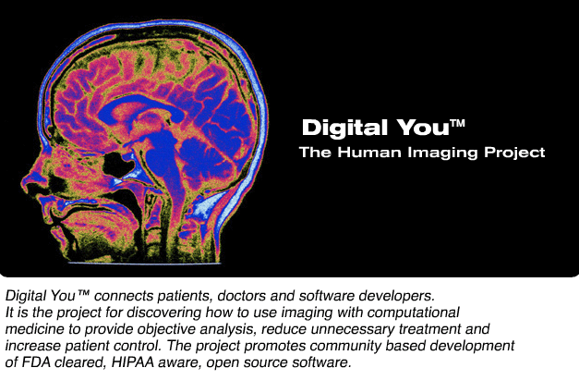

ADRIAN GROPPER, M.D.

Adrian has pioneered the use of computers and the Internet to deliver diagnostics to all physicians. For over 25 years, Adrian has used a combination of engineering and medicine to transition sophisticated diagnostics out of the specialist’s lab and into everyday practice. Today, he’s at the forefront of making diagnostics accessible directly to patients over the World Wide Web.

Adrian’s career as a medical device developer began with undergraduate education in mechanical engineering and computer simulation at MIT, research on early diagnosis of lung disease at the Harvard School of Public Health, graduation from Harvard Medical School in 1978 followed by internship at the University of Oregon Health Sciences Center.

Beginning with a position as Director of Biomedical Research at Orion Research, Inc, Adrian pioneered the field of “physician’s office” diagnostics with the first whole blood analyzer designed for use outside of a laboratory setting. The Orion 1020 introduced the use of embedded computers for fool-proof operation and quality control thereby enabling FDA clearance of a highly sophisticated device outside of a laboratory. Descendants of the 1020 design are still manufactured today by most of the suppliers in the blood electrolyte marketplace.

In 1983, Adrian established his entrepreneurial career as the co-founder of Analytix, Inc. The company developed the first robotic blood analyzer and had an IPO in 1986. In the early 1990’s as the global threat of AIDS became clear, Adrian, working with the leading HIV diagnostic test supplier developed the first low cost, hand-held HIV tester for the developing world.

Adrian’s work on imaging and affiliation with Massachusetts General Hospital began in 1991 with early work on the Center for Innovative Minimally Invasive Therapy a joint project of the MGH departments of radiology and surgery. Over the next few years, Adrian was responsible for the design and deployment of a number of pioneering telemedicine projects throughout the world and, as Chief Technology Officer of RSTAR, Inc, the genesis of the first generation of commercial diagnostic Picture Archiving and Communications Systems (PACS).

In 1995, Adrian Gropper and Sean Doyle founded AMICAS Inc, to bring diagnostic quality images to physicians outside of the radiology department PACS by using Internet technology. AMICAS’ 1997 FDA-clearance of its flagship product preceded the next Web-based image management system by some 18 months. Today, AMICAS’ Web-based PACS technology is installed in over 125 hospitals for use by both radiologists and other physicians. The list of hospitals includes such flagships as MGH, Boston Medical Center, New York Presbyterian and Cornell Medical Centers and The University of Chicago.

From the Orion 1020 to the AMICAS Web PACS, Adrian’s career has consistently pursued the use of computer technology to demystify and remove subjective interpretation from the most broadly applicable diagnostics. Cooperation with and respect for the FDA mandates for advanced diagnostics have been a consistent element of all of his designs as he continues to “push the envelope” in advancing the scientific practice of medicine.

Hugh Cottingham

Sean Doyle

